**Course Three**

# Go Beyond the Numbers: Translate Data into Insights



# Instructions

Use this PACE strategy document to record decisions and reflections as you work through this end-of-course project. You can use this document as a guide to consider your responses and reflections at different stages of the data analytical process. Additionally, the PACE strategy documents can be used as a resource when working on future projects.

# Course Project Recap

Regardless of which track you have chosen to complete, your goals for this project are:

* Complete the questions in the Course 3 PACE strategy document
* Answer the questions in the Jupyter notebook project file
* Clean your data, perform exploratory data analysis (EDA)
* Create data visualizations
* Create an executive summary to share your results

# Relevant Interview Questions

Completing the end-of-course project will help you respond these types of questions that are often asked during the interview process:

* How would you explain the difference between qualitative and quantitative data sources?
* Describe the difference between structured and unstructured data.
* Why is it important to do exploratory data analysis?
* How would you perform EDA on a given dataset?
* How do you create or alter a visualization based on different audiences?
* How do you avoid bias and ensure accessibility in a data visualization?
* How does data visualization inform your EDA?

**Reference Guide**

This project has six tasks; the visual below identifies how the stages of PACE are incorporated across those tasks.

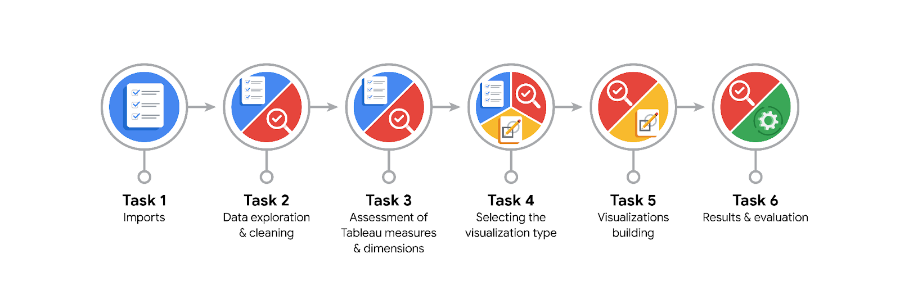

**Data Project Questions & Considerations**

**PACE: Plan Stage**

* What are the data columns and variables and which ones are most relevant to your deliverable?

Claims_status, video_duration_sec, video_view_count, video_like_count, video_comment_count, video_share_count, video_download_count, verification_status, author_ban_status

* What units are your variables in?

Number of view counts

* What are your initial presumptions about the data that can inform your EDA, knowing you will need to confirm or deny with your future findings?
* Is there any missing or incomplete data?

7 columns had incomplete data (over 200 null values)

* Are all pieces of this dataset in the same format?

No

* Which EDA practices will be required to begin this project?

Visualisation

**PACE: Analyze Stage**

* What steps need to be taken to perform EDA in the most effective way to achieve the project goal?

Provide a hypothesis on how user claim or opinion affect view counts and other measures of engagements.

* Do you need to add more data using the EDA practice of joining? What type of structuring needs to be done to this dataset, such as filtering, sorting, etc.?
* What initial assumptions do you have about the types of visualizations that might best be suited for the intended audience?

**PACE: Construct Stage**

* What data visualizations, machine learning algorithms, or other data outputs will need to be built in order to complete the project goals?

Histograms, box plots

* What processes need to be performed in order to build the necessary data visualizations?
* Which variables are most applicable for the visualizations in this data project?

Claims_status, author_status,

* Going back to the Plan stage, how do you plan to deal with the missing data (if any)?

******PACE: Execute Stage**

* What key insights emerged from your EDA and visualizations(s)?

There are far more videos with < 100,000 likes than there are videos with more.

The vast majority of videos are grouped at the bottom of the range of values for video comment count. Most videos have fewer than 100 comments. The distribution is very right-skewed.

Existence of null values

Right-skewed data distribution

* What business and/or organizational recommendations do you propose based on the visualization(s) built?

Claim classification model will need to account for null values and imbalance in opinion video counts by incorporating them into the model parameters.

* Given what you know about the data and the visualizations you were using, what other questions could you research for the team?
* How might you share these visualizations with different audiences?